Sanjel Field Data Acquisition System Requirement

SFDAS requirement derives from legacy FDAS application, enhancement and alteration are needed to pursue overall improvement.

## Modern Architecture

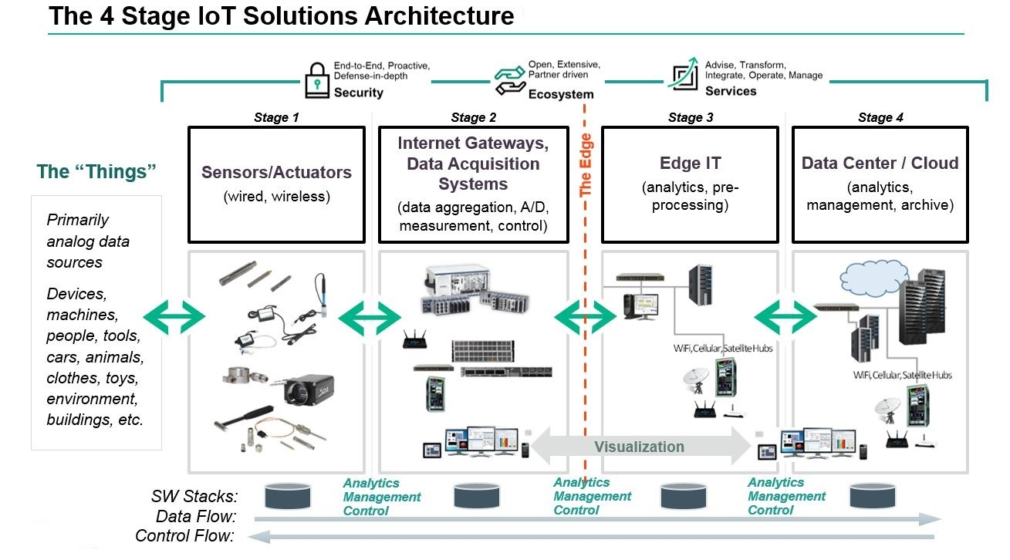

## Collect PLC Data in Real-time

* SCM Data Collector will read data from PLC at 1 hz
* Data will be written to SQLite database
* Data will be written in the following format
  + Time stamp
    - PC value at time of SCM data logging software reading value from PLC
    - UTC, Format TBD
  + JSON string containing name value pairs for all data fields captured
    - Only changed values will be written to the JSON string
    - Attribute names will be coded with integers to reduce the size of the JSON string. An ENUM will be used to decode the integer values
    - JSON string will contain unit number
* Events will not be logged
  + They can be recreated
* All data will be collected and saved in SQLite databse whenever it is available to SCM Data Collector

## Create Digital Monitor to display PLC Data in chart format and flow animation

* Keep the layout (density, rate and pressure charts that are separate and stacked)
* Change the chart colors so that pressure is “Red”
* Chart will show the following values:

|  |  |
| --- | --- |
| Attribute Name | Chart Line Color |
| Density | Green |
| Rate | Blue |
| Pressure | Red |
| Slurry Temperature |  |
| Cumulative Volume |  |

* Identify when a different fluid is pumped
* Chart will use the unit and treatment report data from eService by default
  + When user opened the chart, they will have the option to select a Job from local to plot
  + When chart is opened the start time of the chart will default to Arrive on location time in the Treatment report
  + If no eService Job is selected, chart will plot from current time forward
* Ability for Supervisor to adjust start time and end time on the chart
* Responsive design (change layout based on screen orientation and size)
* Tablet friendly

## Create Job report in PDF

* Ability to print charts to PDF
* PDF printout will include job header information
* Auto populate the header from the selected eService Job – possibly comments as well
* Auto PDF of job chart once complete?

## Configure job parameter for WITS/PLC

* WITS configuration UI to be based on existing FDAS
* Push recipe from eService to SQL Lite for SCM Data collector

## Job Data transmission to Data Center

* All PLC data captured must be transmitted to data center.
* Data will be transmitted as part of the job package.
* All data recorded since the previous Job transmission will be sent with the current job
* Transmission options:
  + Real-time streaming
  + Export package and attach to job package

## eService Online Chart View

* Once data has arrived in the data center, user can open eService online to view the chart

## Job Data analytics tool

* Service infrasture to receive/store PLC data
* Validation mechanism to maintain data integrity
* Ability for EOS to export data from a job to Excel for analysis
* Data will be loaded to Datawarehouse and a PowerBI dataset, providing the ability to dynamic build reports